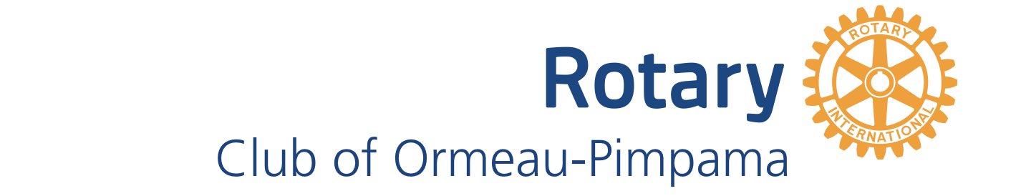

2025 COMMUNITY SUPPORT GRANTS
Background
The Rotary Club of Ormeau-Pimpama has initiated the Community Support Grants to provide funding to support our community organisations to deliver projects which provide benefits to the local community. Each year, the Rotary Club of Ormeau-Pimpama offers a total grants funding of $5000, with each grant up to $1000 for projects by eligible community groups that meet the eligibility criteria. The grants are targeted at supporting projects which strengthen and enrich community life through providing an improved range of leisure, cultural, community development, environmental, health, education, sporting and welfare programs and activities.
Applications for Community Support Grants are received through an annual application round. Once the application period is over, applicants are contacted by members of our Community Support Grants Committee to discuss their applications. Final recommendations by the Community Support Grants Committee are made to the Rotary Club of Ormeau-Pimpama Board in June with applicants being notified shortly thereafter.
Eligibility Criteria
In determining Grant recipients, the following eligibility criteria applies:
- The applicant must be a registered community organization;
- The project must address a need in the local community;
- The project must have a defined outcome that will benefit residents of the local community;
- The funds must be spent within a year and paid upon receipt of quotes and/or invoices; and
- Only one grant application can be submitted up to $1000 for a project per year.
Timeframes
The following timeframes have been determined for the 2025 Community Support Grants:
- Applications are open from 1 May 2025, and close 31 May 2025.
- Final recommendations are made to the Rotary Club of Ormeau-Pimpama Board in June.
- Applicants are notified of grant outcome by 30 June 2025.

How to apply
To apply you must:
- Complete the Rotary Club of Ormeau-Pimpama’s Community Support Grants Application Form.
- Address all eligibility criteria and assessment criteria as specified on the application form
- Attach all required documents as specified in the application form
- Submit your application by email to secretary@ormeaupimpamarotary.org by 5:00pm, 31 May 2025.
Please note: Applicants are strongly advised to review their application prior to submission to ensure it demonstrates how the delivery of the project will benefit the local community.
Acquittal requirements
All projects funded by the Community Support Grants must be acquitted within 4 weeks of project completion or 12 months from the date of approval of funds (whichever is earlier). Any unspent or un-acquitted funds must be returned to the Rotary Club of Ormeau-Pimpama along with a spending report.
Contact us
For all enquiries please contact the Community Support Grants Committee
Email: secretary@ormeaupimpamarotary.org

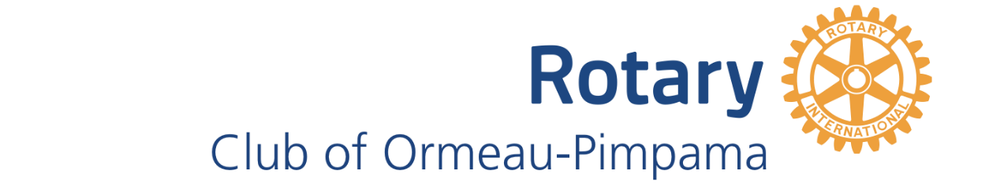

COMMUNITY SUPPORT Grants 2025

Application Information

Name of Community Organization:

Contact Person:

Contact Email:

Telephone/Mobile(home/work):

Bank Details (this must registered under the community group, no individual bank details will be considered)

Name of Bank:

Account Name:

BSB No.: Account No.:
Amount of Funds being applied for (including GST):

Describe the Project

Outline the Benefits of the Project

Detail the group’s proposed financial contribution, resources and/or labour. If part of the funds applied for were allocated would the project be able to proceed?

WHY should the Grants Committee approve this Grant Application?

